 | Document Name | Pacemaker Cluster Troubleshooting
 | Document Number
 | Type of document | WORK INSTRUCTION
 | Revision No: | 1.1

MYLAN
Pacemaker Cluster Troubleshooting
Version 1.1

Revision History

Date | Version | Summary of Changes | Author | Approved by
May 19 2021 | V 1 | Updated Organization Detail | Franklin Kabila Dhas | Arunachalam G
Apr 5 2023 | V1.1 | Updated in New Template | Ashok Kumar RK | Mohandoss Murugesan

Contents
1. Introduction 3
1.1. Objective 3
1.2. Scope of this Report 3
2. Approach and Methodology 3
2.1. Approach 3
2.2. Methodology 3
3. Technical Details 3
3.1. Step 1 3
3.2. Step 2 7
3.3. Step 3 10
4. Roles and Responsibilities 12
5. Escalation Matrix 12
6. Related Documentation 12
6.1. Additional Documentation 12

1. Introduction

1.1. Objective
The objective of this document is to define TACAS configuration when a network device is installed in the Mylan Network

1.2. Scope of this Report
The scope of this report is to define network device TACAS configuration.The procedure described in this document applies to the Global network services group when installing network devices for Mylan.
1.3. Audience
GIDC Unix Operations

1.4. Definitions
- Term: Definition
- Term: Definition

2. Approach and Methodology

2.1. Approach

2.2. Methodology
- Step 1
- Step 2
- Step 3

3. Technical Details

3.1. Step 1
    - Check the running pacemaker processes.
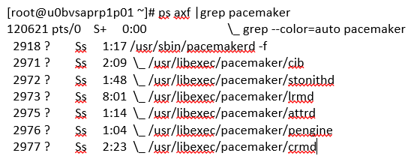
    - Verify the cluster information base using the following command.
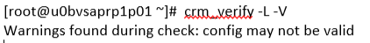
    - Verify the cluster information base using the following command.
[root@u0bvsaprp1p01 ~]# pcs cluster cib
[root@u0bvsaprp1p01 ~]# pcs config show
    - Check the cluster status.
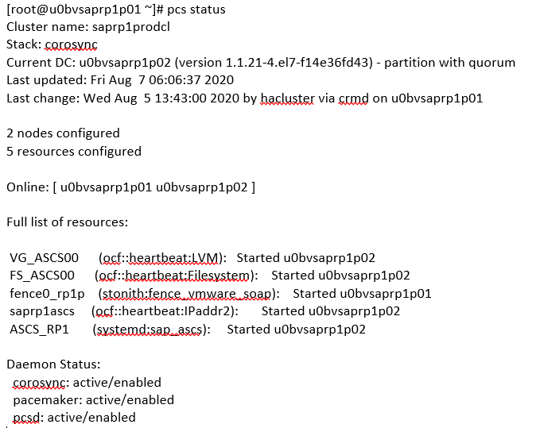
    - Check the corosync communication status.
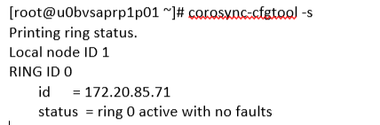
Note: We can have multiple RINGS to provide the redundancy for the cluster communication.

    - Check the membership and quorum API’s.
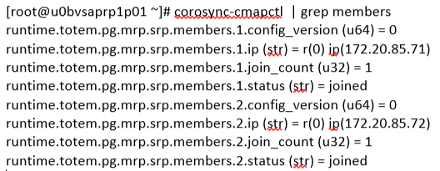
    - Check the corosync status.
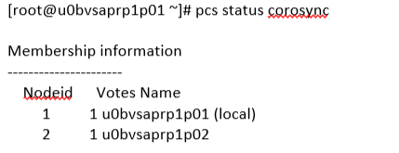
    - View the corosync configuration
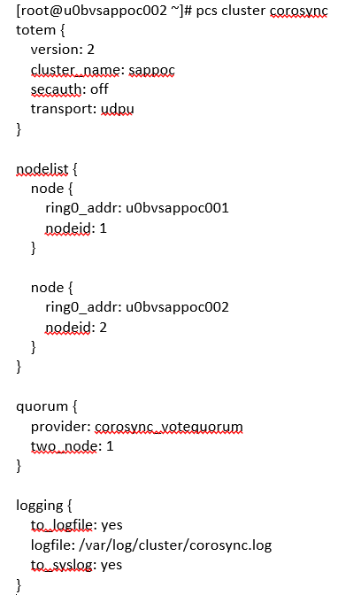
      - To stop the pacemaker resource group ? Just disable the resource group.
[root@u0bvsappoc002 ~]# pcs resource disable <Resource_Group>
root@u0bvsappoc002~]# pcs status
      - To move the resources from Node to Another. In this case, we no need to move each resources manually. We just need to move the Resource group since we have bundled the required resource in to that. If constraint was configured, The dependency resource will move based on the score
[root@u0bvsappoc002 ~]# pcs resource move <Resource_Name> <Node_name>
root@u0bvsappoc002~]# pcs status
      - To Enable the disabled resources and To start the resource group ? Use enable option for the RG
[root@u0bvsappoc002 ~]# pcs resource enable <Resource_Group> or [root@u0bvsappoc002 ~]# pcs resource enable <Resource>
root@u0bvsappoc002~]# pcs status
      - To clear the errors , use the following command
root@u0bvsappoc002~]# pcs resource cleanup
      - To clear the resource fail counts , use the following command.
root@u0bvsappoc002~]# pcs resource clear <Resource>
      - To Check the cluster status.
root@u0bvsappoc002~]# pcs status
      - To stop the cluster services on Node.
root@u0bvsappoc002~]# pcs cluster stop <Node>
      - To stop the cluster services on last Node in cluster.
root@u0bvsappoc002~]# pcs cluster stop <Node> --force
      - To do failover, choose one of the below option
Stop the cluster service from active node.
Fence/ reboot the active node.
Unplug network cable on active node.
      - To move the resource group automatically post server came up(fall back)
      - [root@u0bvsappoc002 ~]# pcs resource ban <Resource> <Node>

3.2. Step 2

3.2.1. Cluster Maintenance Mode: (Online)

If you would like to perform the software upgrades and configuration changes which impacts the cluster resources, you need to make the cluster in to maintenance mode . So that all the resources will be tagged as un-managed by pacemaker. Which means , Pacemaker monitoring will be turned off and no action will be taken by cluster until you remove the maintenance mode. This is one of the useful feature to upgrade the cluster components and perform the other resource changes.
3.2.1.1.To move the cluster in to maintenance mode, use the following command.
[root@UA-HA ~]# pcs property set maintenance-mode=true
      - Check the Cluster Property
[root@UA-HA~]# pcs property list
Cluster Properties:
cluster-infrastructure: corosync
cluster-name: UABLR
dc-version: 1.1.13-10.el7-44eb2dd
have-watchdog: false
last-lrm-refresh: 1452507397
maintenance-mode: true
stonith-enabled: false
3.2.1.3. Check the cluster status. Resources are set to unmanaged Flag.
        - [root@UA-HA ~]# pcs status
Cluster name: UABLR
Last updated: Sun Oct 18 12:19:33 2015 Last change: Sun Oct 18 12:19:27 2015 by root via cibadmin on UA-HA
Stack: corosync
Current DC: UA-HA2 (version 1.1.13-10.el7-44eb2dd) - partition with quorum
2 nodes and 5 resources configured
        - Online: [ UA-HA UA-HA2]
        - Full list of resources:
        - Resource Group: WEBRG1
vgres (ocf::heartbeat:LVM): Started UA-HA2 (unmanaged)
webvolfs (ocf::heartbeat:Filesystem): Started UA-HA2 (unmanaged)
ClusterIP (ocf::heartbeat:IPaddr2): Started UA-HA2 (unmanaged)
webres (ocf::heartbeat:apache): Started UA-HA2 (unmanaged)
Resource Group: UAKVM2
UAKVM2_res (ocf::heartbeat:VirtualDomain): Started UA-HA (unmanaged)
        - PCSD Status:
UA-HA: Online
UA-HA2: Online
        - Daemon Status:
corosync: active/enabled
pacemaker: active/enabled
pcsd: active/enabled
[root@UA-HA ~]#
      - Resources are continuous to run even though you have stopped the cluster services.
        - [root@UA-HA ~]# pcs cluster stop --all
UA-HA: Stopping Cluster (pacemaker)...
UA-HA2: Stopping Cluster (pacemaker)...
UA-HA2: Stopping Cluster (corosync)...
UA-HA: Stopping Cluster (corosync)...
[root@UA-HA ~]# virsh list
Id Name State
----------------------------------------------------
55 UAKVM2 running
        - [root@UA-HA ~]#
        - Perform the maintenance activity which can be done without rebooting the system.
      - Start the cluster services.
        - [root@UA-HA ~]# pcs cluster start --all
UA-HA2: Starting Cluster...
UA-HA: Starting Cluster...
[root@UA-HA ~]#

      - Resource should still show as unmanaged & online.
        - Full list of resources:
        - Resource Group: WEBRG1
vgres (ocf::heartbeat:LVM): Started UA-HA2 (unmanaged)
webvolfs (ocf::heartbeat:Filesystem): Started UA-HA2 (unmanaged)
ClusterIP (ocf::heartbeat:IPaddr2): Started UA-HA2 (unmanaged)
webres (ocf::heartbeat:apache): Started UA-HA2 (unmanaged)
Resource Group: UAKVM2
UAKVM2_res (ocf::heartbeat:VirtualDomain): Started UA-HA (unmanaged)
      - Clear the Maintenance mode.
[root@UA-HA ~]# pcs property set maintenance-mode=false
OR
[root@UA-HA ~]# pcs property unset maintenance-mode
      - Verify the resource status.
        - [root@UA-HA ~]# pcs status
Cluster name: UABLR
Last updated: Sun Oct 18 12:41:59 2015 Last change: Sun Oct 18 12:41:51 2015 by root via cibadmin on UA-HA
Stack: corosync
Current DC: UA-HA2 (version 1.1.13-10.el7-44eb2dd) - partition with quorum
2 nodes and 5 resources configured
        - Online: [ UA-HA UA-HA2 ]
        - Full list of resources:
        - Resource Group: WEBRG1
vgres (ocf::heartbeat:LVM): Started UA-HA2
webvolfs (ocf::heartbeat:Filesystem): Started UA-HA2
ClusterIP (ocf::heartbeat:IPaddr2): Started UA-HA2
webres (ocf::heartbeat:apache): Started UA-HA2
Resource Group: UAKVM2
UAKVM2_res (ocf::heartbeat:VirtualDomain): Started UA-HA
        - PCSD Status:
UA-HA: Online
UA-HA2: Online
        - Daemon Status:
corosync: active/enabled
pacemaker: active/enabled
pcsd: active/enabled
[root@UA-HA ~

3.3. Step 3
    - VG and LV not found in one of cluster node.
Issue: Failed Resource Actions:
      - FS_ASCS00_start_0 on u0bvsapgeq002 'not installed' (5): call=35, status=complete, exitreason='Couldn't find device [/dev/clustervg/clusterlv01]. Expected /dev/??? to exist',
last-rc-change='Wed Aug 12 02:23:16 2020', queued=0ms, exec=143ms
Cause:
Unproper Constratint
Not a unique Disk name in both the server.
Resoultion:
Unproper Constratint
- set the order and colocation constraint
- clean the error
Not a unique Disk name in both the server.
- Stop and Disable lvm2-lvmetd.socket service
- stop and enable lvm2-lvmetad.service
- rebuild and update to kernel module.
- reboot the server.
Diagonstic step:
Issue1: “pcs constraint show” to validate order and colocation constraint
Issue 2: lsblk to validate disk name.
    - VG and LV not found in one of cluster node.
Issue: Failed Fencing Actions:
reboot of u0bvsapgeq001 failed: delegate=u0bvsapgeq002, client=stonith_admin.5595, origin=u0bvsapgeq002, last-failed='Wed Aug 12 03:04:13 2020‘

Cause:
Fence configuration.
Vm snapshot
Resolution:
Validate and reconfigure fencing if required. Validate required permission available for the service account.
Remove all snapshots and enable “NOBACKUP” annotation at Vmware level and move the server to file system backup.
Chang scsi.ctk.enabled to disk to false (work around)

Roles and Responsibilities

Sl. No. | Roles | Responsibilities | Team Member Name
1. | Maintenance Window | Respective Team / Unix Team | GIDC.unix_Run  GIDC.unix_Run@viatris.com
2. | Change Request | Respective Team / Unix Team | GIDC.unix_Run  GIDC.unix_Run@viatris.com
3. | Change Implementation | Respective Team / Unix Team | GIDC.unix_Run  GIDC.unix_Run@viatris.com
4. | Hyper Care | Respective Team / Unix Team | GIDC.unix_Run  GIDC.unix_Run@viatris.com

5. Escalation Matrix

Person Responsible | Role | Triggers When
Arun R  Arun.R@viatris.com  +91 9710677240 | SME
Ashok Kumar R K  AshokKumar.RK@viatris.com  +91 9967735890 | Manager
Mohandoss Murugesan  Mohandoss.Murugesan@viatris.com  +91 6366966170 | Senior Manager

6. Related Documentation

6.1. Additional Documentation

